Department of Electronic & Electrical Engineering

MEng/BEng in CES
EE475 Individual Project

This document is organised in to four parts:
PART 1: STATEMENT OF INTENT
PART 2: PROJECT WORK PLAN
PART 3: RESOURCE REQUIREMENT
PART 4: RISK ASSESSMENT
PART 5: SAFETY DECLARATION
- All parts of the form must be completed jointly by the student and Project Supervisor, and lodged (by the student) with in R4.01(EEE Resource Centre) by 14.00 on 12th October 2018.
- Copies of the completed form will be sent to the Project Supervisor and Second Assessor.
- The student is advised to retain a copy of the completed form for future reference.
- Students will be asked to reflect upon parts 1, 2 and 4 in the interim reports and also in the final report.

Supervisor’s Name:  Dr Sergey Kitaev | Student’s Name:  Christopher Richmond
Project Title:
Vector Racer

PART 1: STATEMENT OF INTENT
The purpose of this section is: (i) to provide a concise description of the project, and (ii) to state a set of objectives that will provide the guide for assessing the project. Students should note the importance of item (ii), which should be discussed in detail with their project supervisors.
A. Project Description:
The student, in consultation with the Project Supervisor, is required to describe the project in his/her own words in the space provided below (in about 200 to 300 words). Note that simply copying descriptions in the project listing is unacceptable. THIS PART SHOULD NOT BE COMPLETED BY THE PROJECT SUPERVISOR other than ensuring the accuracy of the description. DO NOT ATTACH EXTRA PAGES.

This project involves the creation of a piece of software which simulates a 2-dimensional, turn-based, grid racing game whose rules are primarily governed by geometry and vector mathematics. The player guides their “racer” around predesigned tracks to reach a goal, and is limited in their movement options on any given turn by their current velocity, thus simulating real-world acceleration/deceleration. The faster (number of grid squares travelled per turn) a player’s vehicle is travelling, the longer it will take for them to halt and vice versa. This makes for an interesting racing dynamic as the player must consider several turns in advance how they will approach a corner, as speeding round sharp bends isn’t possible without crashing. The player may play against another player or the computer AI. This project also poses an open-ended yet significant challenge pertaining to developing a computer vehicle AI which can navigate varying racetracks with a high level of efficiency regarding the amount of time/moves it takes to complete each track when compared with a skilled human player.
B. Project Objectives:
Project objectives must be stated in such a way that they can be translated into achievable goals during the conduct of the project. For this reason, the stated objectives must be specific and realistic to be attained within the time provided. It will be very helpful if supervisors encourage their students to come up with initial objectives from students’ perspective as this exercise could help students to better understand the aims of the project. It is important to note that the achievements of the project work will be measured against the objectives stated here. Copies of this section will be made available to persons involved with the assessment of this project.

To Project Supervisor:
- Under the “Importance” column below, enter one of the following as appropriate: “Major", “Minor", or “Optional”.
- If at a later stage the project objectives change significantly from those stated here, the changes must be communicated to the Second Assessor. Please make a copy to the Year Co-ordinator, Dr D. Harle.

Project Objectives | Importance
Design and produce a software application which successfully mirrors the pen and paper game “Racetrack”; a turn-based grid racing game whereby a player can alter the velocity of their vehicle by ±1 along both the x and y axis on any given turn - in order to simulate velocity in vector mathematics | Major
Support Player vs Player gameplay | Major
Provide a variety of predesigned tracks for the player to access | Major
Implement an AI algorithm for navigating racetracks efficiently in order to support Player vs Computer gameplay | Minor
Implement a Track Editor feature to allow the user to create their own racetracks | Optional

PART 2: PROJECT WORK PLAN
Identify project milestones and summarise your work plans in the table below in the order you do them. (Example: preliminary design, prototyping, simulation modelling, results validation, write-up, etc.).

 | Project Milestones/Work Phases | Expected Week Time  Enter start and end week  Ex.: Week 6 to week 8
1 | PRELIMINARY DESIGN – Brief Requirements Document based on objectives outlined in Statement of Intent, Class Diagram, Project Plan (Gantt Chart), GUI wireframes/mock-ups, any additional supporting documentation | Semester 1  Week 3 – Week 6
2 | PRELIMINARY RELEASE – Revised Requirements Doc., Revised Class Diagram, Updated Project Plan, Rough Testing Strategy Plan, Prototype(s) demonstrating some basic game functionality | Semester 1  Week 6 – Week 11
3 | INTERMEDIARY RELEASE – Revised Class Diagram, Finalised Testing Strategy, Working game protoype with most key functionality now in place | Semester 2  Week 1 – Week 5
4 | FINAL RELEASE – Final Class Diagram, Test Results, Final working version of the game with core functionality and any additional features, debugging carried out | Semester 2  Week 5 – Week 9
5 | WRITE UP – Final Report + any other documentation left unfinished by this point | Semester 2  Week 7 - Week 10

PART 3: RESOURCE REQUIREMENT

A. Software:
List the software required for the project. This includes programming languages, application packages, CAD tools, etc.

Software  (indicate version no. if applicable) | Software Administrator  (CS Dept, EEE Dept, Comp. Centre) | Target Use  (teaching, research,etc.) | Platform  (PC, workstation) | Expected Usage (hours/week)
IntelliJ IDE 2018.x.x | CS Dept | Software dev. | PC | 20-25
Java 10 | CS Dept | Software dev. and runtime environment for prototypes | PC | 20-25
Windows 10/Linux Ubuntu | CS Dept | Software dev. and multi-platform testing for prototyping | PC | 20-25

B. Hardware:
List major hardware components such as circuit boards, LSI/VLSI integrated circuits, and special purpose components.

n/a

C. Laboratory/Work Area:
Indicate the laboratory room(s) and/or project work area for the project.
Livingstone Tower 11th, 12th, and 13th floor labs

D. Logbook:
Confirmation that student has A4, hardback, bound logbook that has been viewed by the supervisor. YES/NO (delete one)

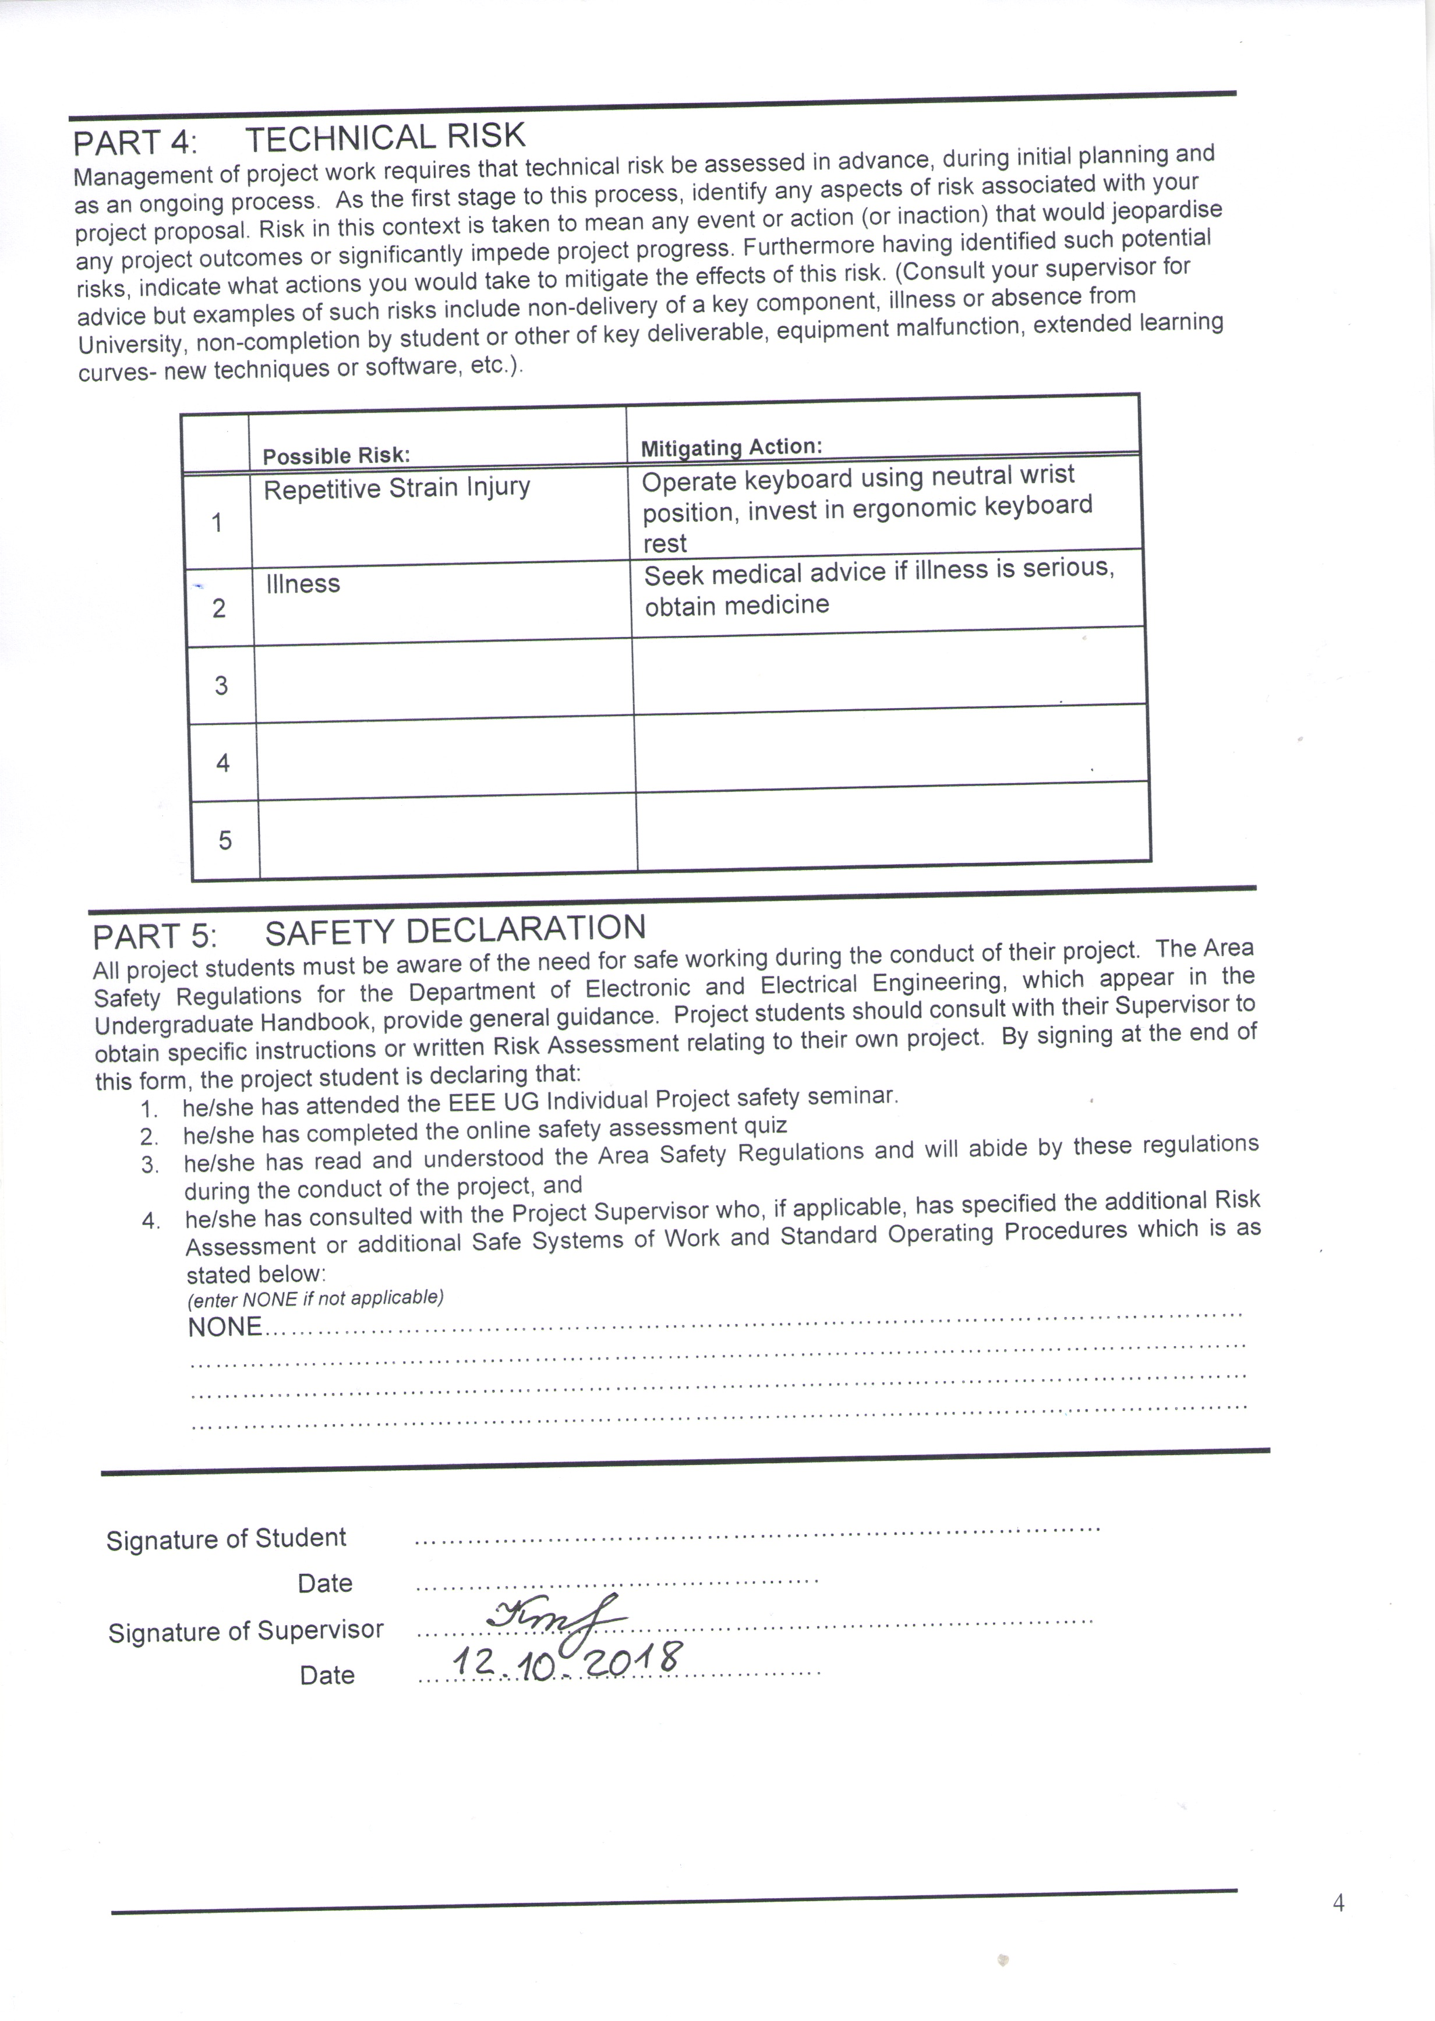
PART 4: TECHNICAL RISK
Management of project work requires that technical risk be assessed in advance, during initial planning and as an ongoing process. As the first stage to this process, identify any aspects of risk associated with your project proposal. Risk in this context is taken to mean any event or action (or inaction) that would jeopardise any project outcomes or significantly impede project progress. Furthermore having identified such potential risks, indicate what actions you would take to mitigate the effects of this risk. (Consult your supervisor for advice but examples of such risks include non-delivery of a key component, illness or absence from University, non-completion by student or other of key deliverable, equipment malfunction, extended learning curves- new techniques or software, etc.).

 | Possible Risk: | Mitigating Action:
1 | Repetitive Strain Injury | Operate keyboard using neutral wrist position, invest in ergonomic keyboard rest
2 | Illness | Seek medical advice if illness is serious, obtain medicine
3
4
5

PART 5: SAFETY DECLARATION
All project students must be aware of the need for safe working during the conduct of their project. The Area Safety Regulations for the Department of Electronic and Electrical Engineering, which appear in the Undergraduate Handbook, provide general guidance. Project students should consult with their Supervisor to obtain specific instructions or written Risk Assessment relating to their own project. By signing at the end of this form, the project student is declaring that:
- he/she has attended the EEE UG Individual Project safety seminar.
- he/she has completed the online safety assessment quiz
- he/she has read and understood the Area Safety Regulations and will abide by these regulations during the conduct of the project, and
- he/she has consulted with the Project Supervisor who, if applicable, has specified the additional Risk Assessment or additional Safe Systems of Work and Standard Operating Procedures which is as stated below:
(enter NONE if not applicable)
NONE…………………………………………………………………………………………………
…………………………………………………………………………………………………………
…………………………………………………………………………………………………………
…………………………………………………………………………………………………………

Signature of Student ……………………………………………………………………
Date ……………………………………….
Signature of Supervisor …………………………………………………………………..
Date ……………………………………….

